**Assignment 1 🡪 Pipeline – 3 Jobs and 1 Main job**

**Slave1-httpd-index-deploy**

**Slave2-httpd-index-deploy**

**Slave3-httpd-index-deploy**

**Jenkins-master**

**22Q1-clone**

**22Q2-clone**

**22Q3-clone**

**Git Repo**

**Step 1:** Launch & connect 3 slaves instances 🡪 slave1, slave2, slave3

yum install httpd –y 🡪 service httpd start

chmod –R 777 /var/www/html

yum install java-1.8.0-openjdk-devel.x86_64 –y

**step 2: Create Nodes/agent**

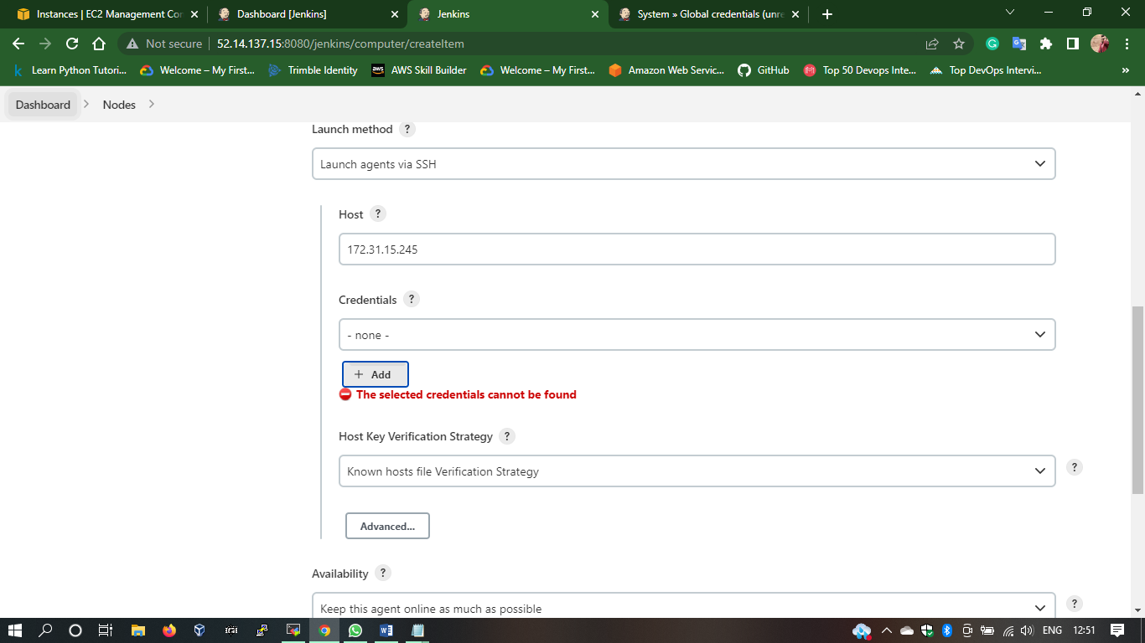

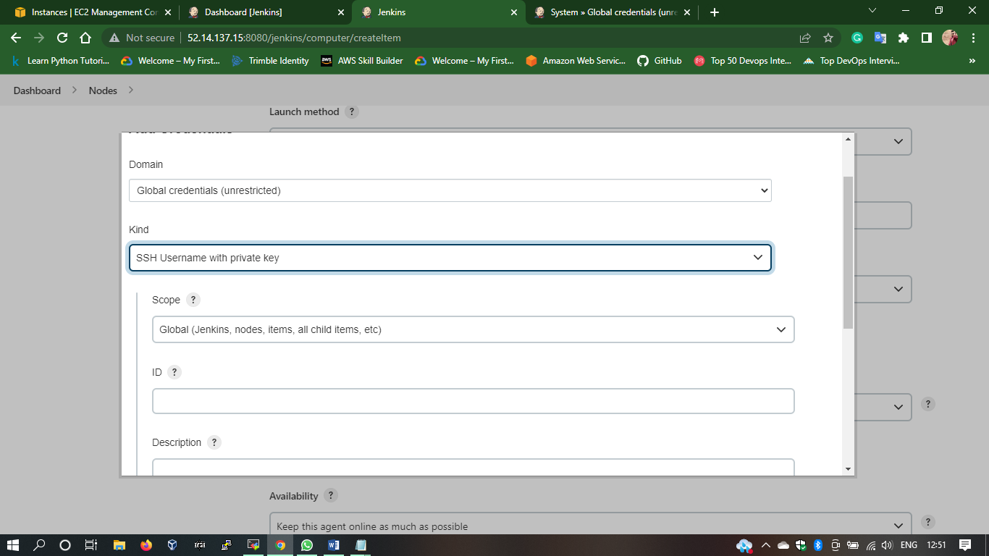

**Step 3: Create 3 pipeline jobs 🡪 Slave1, Slave2, Slave3**

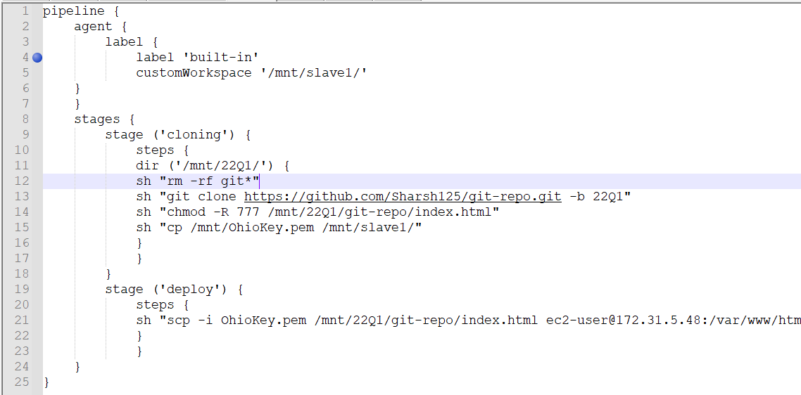

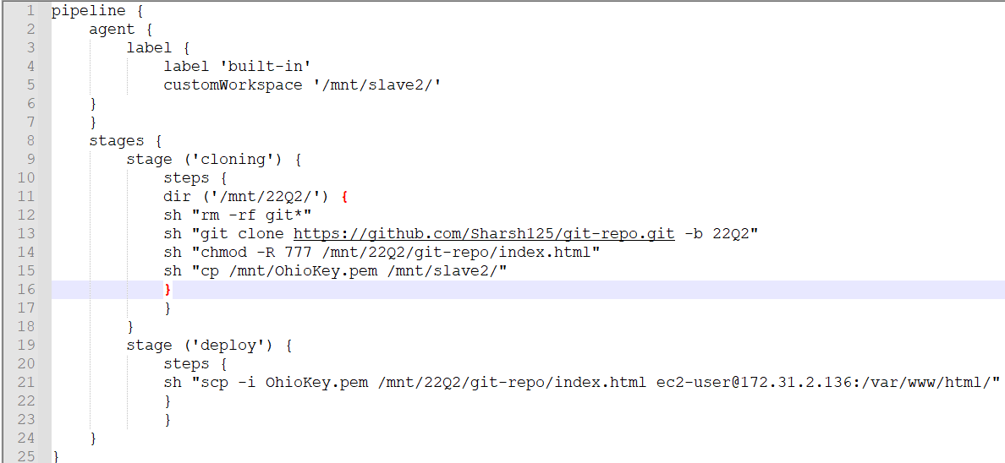

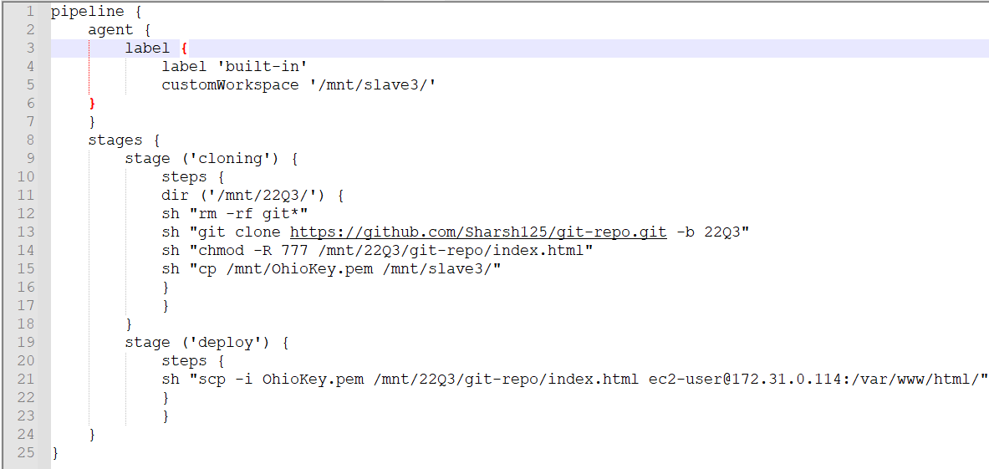

**Step 4: Create Main pipeline & call 3 slaves jobs 🡪 jm-slaves-index-deploy**

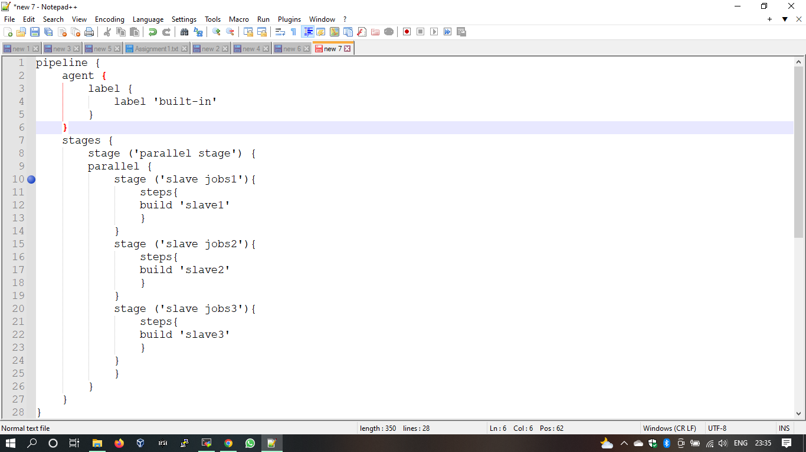

**Result :**

